此文章已于 15:35:21 2017/11/15 重新发布到 HealerJean梦想博客

PowerDesigner相关操作

## 1、[PowerDesigner导入sql脚本生成物理模型](http://www.cnblogs.com/zsswpb/p/5771623.html)

### （1）首先从生成一个sql脚本

|  |
| --- |
| create table CSIP_OA_PLAN  (  COLUMN1 VARCHAR2(50),  COLUMN2 VARCHAR2(50),  COLUMN3 VARCHAR2(50),  COLUMN4 VARCHAR2(50),  COLUMN5 VARCHAR2(50),  )  comment on column CSIP_OA_PLAN.COLUMN1  is '备用字段1';  comment on column CSIP_OA_PLAN.COLUMN2  is '备用字段2';  comment on column CSIP_OA_PLAN.COLUMN3  is '备用字段3';  comment on column CSIP_OA_PLAN.COLUMN4  is '备用字段4';  comment on column CSIP_OA_PLAN.COLUMN5  is '备用字段5'; |

### （2）打开PowerDesigner，打开File——>Reverse Engineer——>Database...

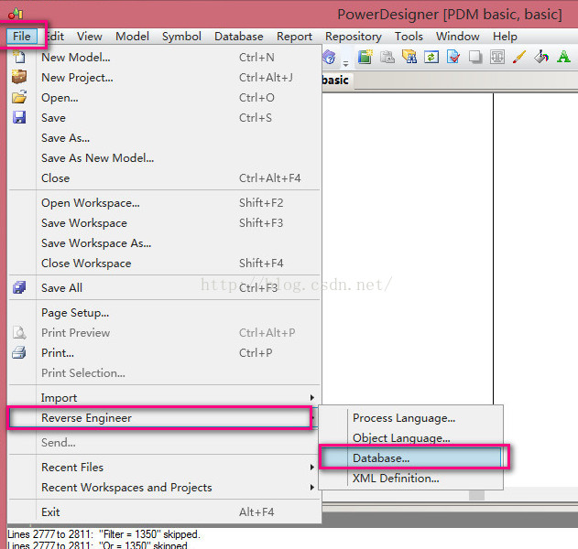

### （3）弹出弹框，更改Model Name的名字。注意DBMS选择 Microsoft SQL Server2008

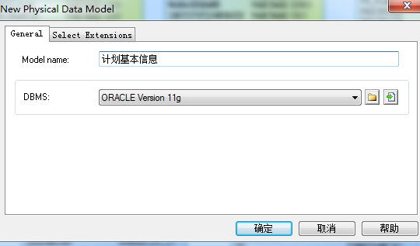

### （4）点击确定，弹出下框。选择Using script files，按照图中步骤操作。

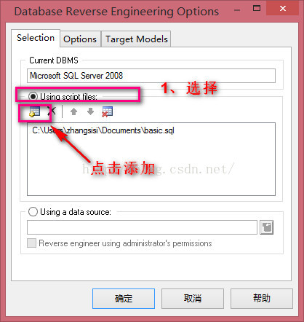

### （5）选择要导入的脚本，点击确定即可生成表结构

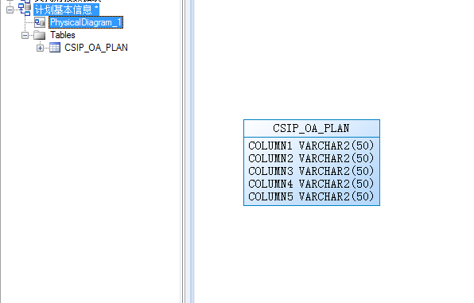

## 2、文件名字的改变

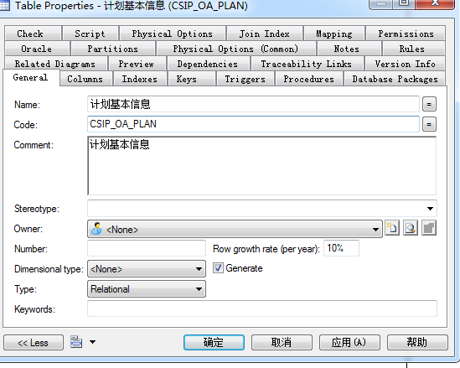

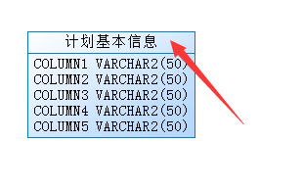

## 3、column 显示注释，可以选择显示的列的名字，包括注释comment

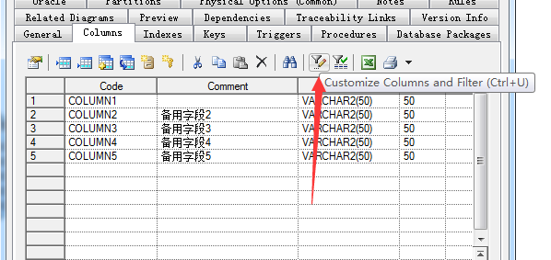

## 4、修改颜色，长度

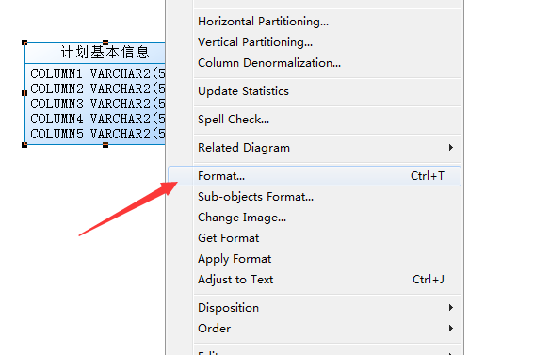

### 1、长度

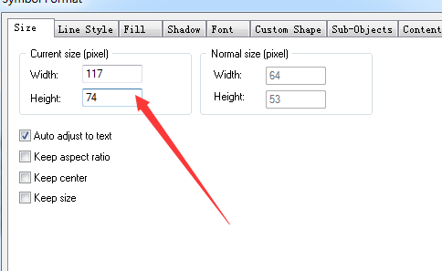

### 2、背景颜色

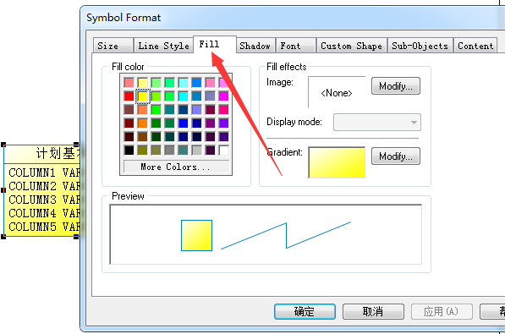

## 5.、将页面中显示的字段英文改成comment中文

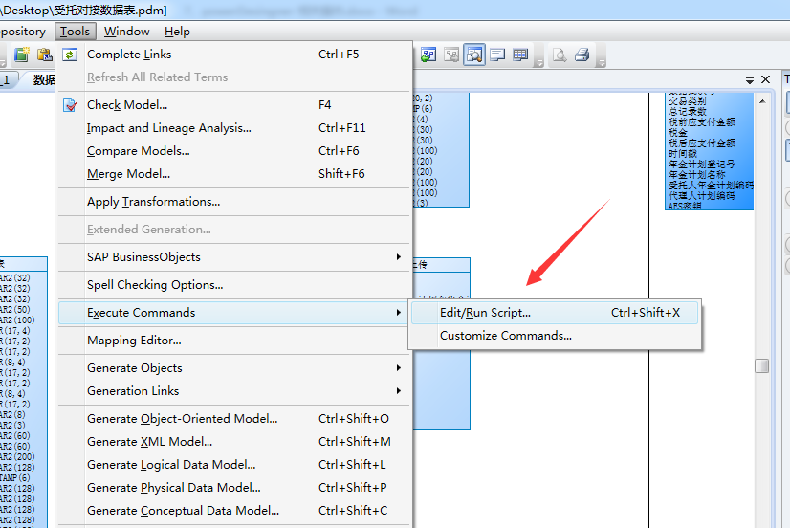

|  |
| --- |
| Option Explicit  ValidationMode = True  InteractiveMode = im_Batch  Dim mdl ' the current model  ' get the current active model  Set mdl = ActiveModel  If (mdl Is Nothing) Then  MsgBox "There is no current Model "  ElseIf Not mdl.IsKindOf(PdPDM.cls_Model) Then  MsgBox "The current model is not an Physical Data model. "  Else  ProcessFolder mdl  End If  Private sub ProcessFolder(folder)  On Error Resume Next  Dim Tab 'running table  for each Tab in folder.tables  if not tab.isShortcut then  tab.name = tab.comment  Dim col ' running column  for each col in tab.columns  if col.comment="" then  else  col.name= col.comment  end if  next  end if  next  Dim view 'running view  for each view in folder.Views  if not view.isShortcut then  view.name = view.comment  end if  next  ' go into the sub-packages  Dim f ' running folder  For Each f In folder.Packages  if not f.IsShortcut then  ProcessFolder f  end if  Next  end sub |